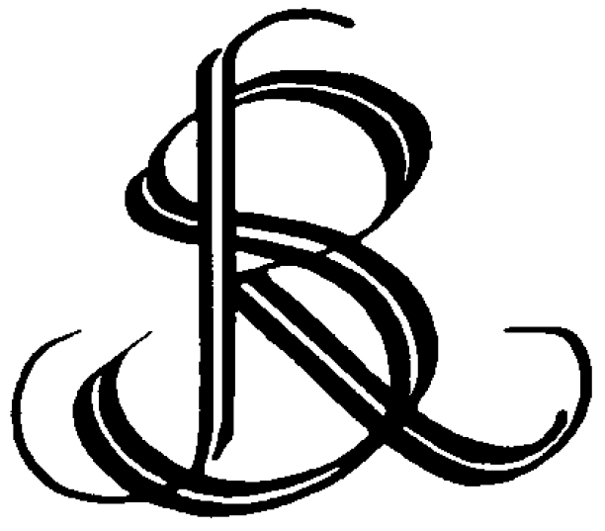 | T H E R E I G A T E S O C I E T Y
 | Civic Awards Form
Nominations for Civic Awards are invited for any of the following categories.
New buildings
Conversions, improvements and adaptations
Conservation and restoration
Exterior decoration
Street or road layout improvements
Tree planting, gardens and landscaping
Nominations should be for work carried out within the Borough, including Redhill, Reigate and Merstham. Nominations should be completed within the 12 months up to 11th July of the current year, and may be proposed at any time during the year by a member of The Reigate Society or any interested member of the Public.
Nominations will be judged on the basis of design quality, construction excellence, suitability of finish, context and setting, respect for heritage, conversion sensitivity, and usefulness to the community. Previous awards may be examined on the Society website at http://www.reigatesociety.org.uk/about/society-awards.php
Name and address of project (with post code):

Contact details of project owner, tenant, architect, designer, developer, agent, other:
Name:
Address (with post code):
email:
Phone / mobile:
Reasons for nomination:

Name and address of proposer:

Phone & email contact details of proposer:

This completed form should be sent -
to: Gwyther Joyce, Chairman Architecture and Planning Committee, The Reigate Society, 10 Priory Drive, Reigate RH2 8AF,
or email: gwyther.joyce@ntlworld.com

